Food in prison
Unit 3
Eating in prison

Contents

Unit 3 Food in prison teacher’s notes

Unit 3 Food in prison learner resources

Unit 3 Food in prison answers

Unit 3 Video – What Do You Think of Prison Food?

Copyright - please read
All the materials on these pages are free for you to download and copy for educational use only in your establishment. You may not redistribute, sell or place these materials on any other website without written permission from the British Council. If you have any questions about the use of these materials please email us at: esolnexus@britishcouncil.org

Unit 3 - Teachers’ notes
This unit focuses on learners describing and talking about food in prison. The grammar focus is on adjectives and the use of quantifiers with countable and uncountable nouns. Learners will practise creating headlines about prison food using adjectives for dramatic effect. They will then create their own headlines using given adjectives. It is intended mainly for learners at Entry 2 – 3. Provision is made for extension activities for quicker learners and many tasks are differentiated for mixed ability groups.
The film script was based on real prisoners’ responses to the question, ‘What do you think of prison food?' Learners will identify the use of quantifiers in the clip and then talk about prison food using learnt grammar.
Teachers can extend the units to provide more practise of a particular feature if required e.g. new activities can be created using the video, but focusing on different features of language, for example, adverbs of frequency

Time: 110 minutes plus extensions.

Level: Entry level 1-3 / Scottish National 2 – National 4 / CEFR A1 – B1

Aims
- to introduce language to talk about food
- to use adjectives to describe food
- to use quantifiers with countable and uncountable nouns

Objectives
All learners will be able to:
- read and identify some adjectives used to describe food
- use quantifiers with some countable and uncountable nouns
- give their opinion and describe prison food
- spell some key words associated with food.
- use a lot and many with countable and uncountable nouns.
Entry 3 / National 4 learners will be able to
- use positive and negative quantifiers; enough/ not enough/ too much/ too many.

Preparation
You will need:
- Resource 1: one copy to display or one copy for 2-3 learners.
- Resource 2: one set of adjective cards for each pair of learners (cut up).
- Resource 3: one copy of headlines to display to learners
- Resource 4a: one copy each for learners at lower levels
- Resource 4b: one copy each for learners at higher levels
- Resource 5: copy of video – What Do You Think of Prison Food? and device to play it
- Resource 6a: (lower level) / b (higher level - optional)
- Resource 7: audioscript of video
- Resource 8: one set of domino cards cut up for each group of learners.
- Extension resources 9 and 10: 2 extra or homework activities
- A4 or A3 paper to write headlines for Activity 1.

Tip: the printed resources could be laminated for future use

Warmer: Adjectives to describe food (15 minutes)
- Display resource 1 and elicit the topic. Ask learners to identify the food items / fruit / vegetables in the picture.
- Put learners in pairs and hand one set of adjective cards to each pair (Resource 2). Ask learners to pick out those adjectives that can be applied to food.
- Drill pronunciation/ stress.
- Ask learners for examples of a food that each adjective could describe. This task will be personal to each learner and group so can prompt discussion on various likes / dislikes.
- Elicit understanding of remaining/ new adjectives and provide examples e.g. mime eating something and make a face that shows think it is awful; hold your ear to signify loud music.
Differentiation / extension
- Quicker learners can add adjectives to the food list from their own knowledge.
- Pre-entry learners: once the rest of the group are matching adjectives to food, work with these learners on about 4 of the adjectives.
Activity 1 – Making headlines (15 minutes)
- Display the headlines from resource 3 on a projector/ interactive white board (IWB).
- Ask learners where they might see headlines and to identify the adjectives in each headline.
- Elicit the purpose of an adjective (to describe the noun – make headline more interesting). Elicit whether the adjectives are positive or negative.
- Write the following adjectives on the board (or choose adjectives relevant to your learners): fresh; angry; happy; boring cheap; overcooked; nice; fat; tasty; frozen.
- Make a simple headline on the board using the adjectives e.g. ‘Prison food isn’t boring’ ‘All prison meat is frozen’. Elicit further examples.
- Talk about the food in your establishment. How would learners describe the food they get? Write the nouns and adjectives they use on the board. Ask questions to check everyone understands the vocabulary.
- Work with the whole class to make up a headline about the food in your establishment.
- When you are confident that learners have grasped the concept, group them with learners of a similar level and ask them to write 1-4 headlines in pairs or threes.
- They then read out, or tell the class, their headline. Work with them to help correct any grammatical issues.
- Put the corrected versions up on the wall so they have a model of correct spelling and grammar.
Differentiation/ extension
- Low levels and learners with literacy needs: once the others are working ask them to say a headline and write it for them. They could then read their own headlines.
- Higher level learners: suggest they use more than one adjective in a headline e.g. ‘Prisoners angry about boring food.’

Activity 2: Listening for gist – prisoners talk about prison food (10 minutes)
- Explain that you are going to play a short film clip with 4 prisoners talking about food and elicit whether learners think the prisoners will like the food or not.
- Display resource 4a and focus learners on the second column only.
- Model the first answer then play clip through once and learners tick whether each prisoner likes the food or not.
- Elicit the correct answers.
Differentiation
Resource 4b is a lower-level activity with options to choose from. If you use this version, model this one instead of the blank version then explain to the higher level learners that they should write something similar in the next boxes.

Activity 4 – Listening for detail (15 minutes)
- Explain to learners that they are now going to listen for why the prisoners like / dislike the food and write comments in the third column of resource 4a.
- Play the clip through as many times as it takes for the learners to obtain all the information. They are listening for detail and there are a variety of options, so elicit feedback at the end and correct grammar.
Differentiation
- Lower level learners: write T (true) or F (false) beside each comment in the third column of resource 4b.
- For higher level learners: point out that ‘ain’t’ is slang for isn’t / aren’t/ haven’t and although learners will hear it spoken, it is not standard English.
- For higher level learners: elicit meaning and examples of countable/ uncountable nouns
- For higher level learners: highlight that too much / too many have a negative meaning – ‘There’s too much pasta.’
Activity 5: Speaking about prison food – good and bad things (10 minutes)
- Learners work in pairs/ small groups. Tell learners they are going to talk about prison food. Elicit 3 positive things to say e.g. ‘There are always lots of vegetables.’ ‘Sunday lunch is very tasty’
- Then elicit 3 negative things to say e.g. ‘There isn’t enough variety.’

Activity 6: Quantifiers (15 minutes)
- Group the learners by level then draw a line at the top of the board. At one end write not much/ many at the other write a lot/ lots of.
- Elicit where some/ a few/ enough/ not enough would go on the line.
- Play the clip through again prisoner by prisoner and ask learners to identify one example of a quantifier. You could either write this on the board under the relevant quantifier, or hand out resource 6a for learners to write down what the speaker is referring to e.g. Kevin says; ‘There isn’t much left.’ Kevin is referring to food which is uncountable. Sid says ‘There’s not enough choice’. Sid is again referring to food which is uncountable.
Differentiation/ extension
- Lower level learners: use fewer quanitifiers e.g. not many, some, a lot. With a mixed group, once the higher level learners understand the task work with the lower level learners to identify the more limited list of quantifiers. You could write them on a piece of paper then the learners can point to them as they listen. After listening they could read again or write simple sentences e.g. ‘We don’t have many vegetables’.
- More proficient learners can identify a use of more than one quantifier for each prisoner.
- Higher level learners can complete resource 7b and insert the correct quantifier.
- Learners could read the audioscript while listening.

Activity 7 – Dominoes game (15 minutes)
- Tell the learners they are going to play a game where the aim is to match the countable or uncountable item with a grammatically correct quantifier.
- Put learners into groups of 2-3 according to their level. Display the dominoes (resource 8) on the board ask learners whether the food items on their cards are countable or uncountable.
- Model some examples of how to match the quantifiers and nouns either using the dominoes or on the board.
- Hand out cards from resource 8. Learners share cards out (ideally groups of 3 with 4 cards each) then take it in turns to put a card out so the quantifier collocates with the noun like dominoes.
- When the learners have finished the game they should make as many sentences as they can.
Differentiation/ extension
- Work with the lower level learners to assist them to make sentences
- Learners could write their sentences either in class or for homework.

Cooler: Speaking about prison food – opinions (15 minutes)
- Ask learners to interview each other in pairs about what they think about the food in their prison.
- Start by eliciting the questions used in the video while encouraging them to come up with questions of their own.
Differentiation
- More advanced learners could answer the question ‘What do you think about the food here?’ using quantifiers in their response.
- Less proficient learners could be asked to describe their most recent meal or another meal they really enjoyed or hated.

Follow up/ homework activities
Extension resource 9: Gap fill – adjectives
Learners should fill in the adjective that matches the clue in brackets.

Extension resource 10: Anagrams – vocabulary and spelling
- Ask learners if they can name some of the food mentioned in the film.
- Hand out the anagram sheet and explain that the words are mixed up. Learners work in pairs. Set a time limit to see who completes all words first. Alternatively, project the anagrams or write them on a white board – learners can come up to the board and complete the game with the help of the class.
- Ask learners to turn the answers over and nominate individuals in turn to spell some of the words.
Differentiation
In a mixed ability class, pair a weaker learner with a stronger learner, or supply the first letter of the answer to some learners.

Further follow up activities
- Go back to the headlines that the learners made up in Activity 1 and ask the learners to choose one as the heading for an article. Use it as the stimulus for a group language experience activity eliciting their own ideas and opinions about the topic. They could then write an article about the discussion.
- You could choose one positive and one negative headline to create ‘articles’ of four or five sentences.
- Ask learners to work in threes to discuss and decide on questions they would like to ask the catering manager in an interview. If possible and appropriate, invite the catering manager to meet and talk to your class.
- Learners interview each other about food/ dishes they like and dislike. They could create a class chart using resource 4a as a model and draw or write the foods. The main purpose of the activity would be to encourage as much discussion to consolidate and extend what they have learnt in the session.

Resource 1: Food

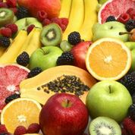 | 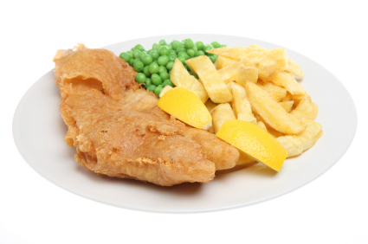 | 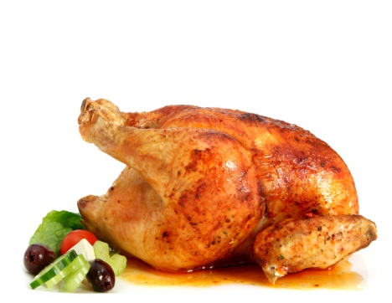
 | 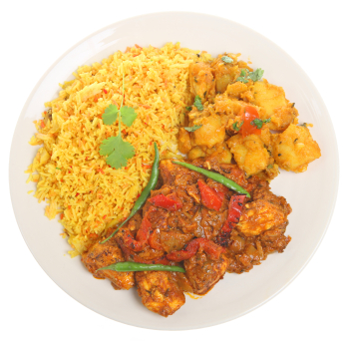 | 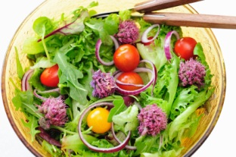
 | 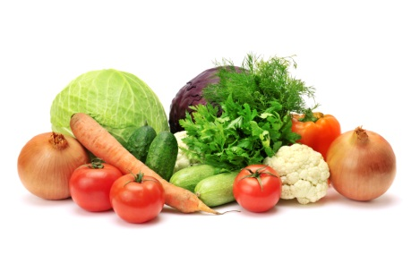 | 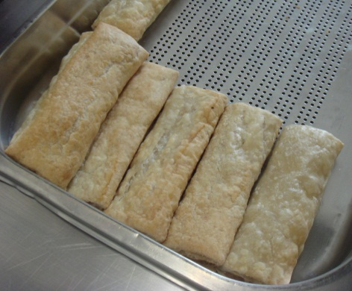
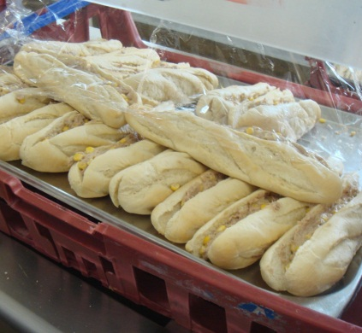 | 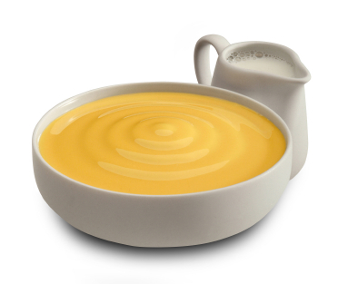 | 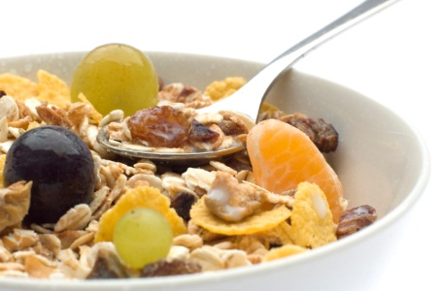

Resource 2: Adjectives
tall | long
tasty | unhealthy
loud | horrible
salty | handsome
thick | delicious
awful | sweet
Resource 3: Headlines
More money spent on dinners for lucky prisoners than school lunches

Prisoners enjoy tasty food

Food in UK prisons horrible

Prisoners angry about unhealthy food

Delicious menu for inmates this Christmas

Resource 4a: Talking about prison food

Name of speaker | Like =  Dislike = x  OK | What does he like?  What does he dislike?
Kevin

Sid

Paul

Dan

Resource 4b: Listening to prisoners
Name of speaker | Like = √  Dislike = x  OK | What does the prisoner say? Put T (true) or F (false) next to each comment.
Kevin |  | - He likes fish and chips.  - He has sandwiches at lunchtime.  - He eats his lunch in the dining hall.
Sid |  | - The food tastes horrible.  - Sid isn’t a vegetarian.  - There are a lot of vegetables in the summer.
Paul |  | - He loves prison food.  - There’s too much rice and pasta.  - He has an egg for breakfast.
Dan |  | - He had an omelette with rice yesterday.  - He hates the pasta meals.  - They do lots of different sauces.

Resource 6a: listening in detail
Name | much/ too much | enough/ not enough | a lot of/ lots of
Kevin
Sid
Paul
Dan
Lenny
Catering manager

Resource 6b: listening to prisoners in detail

Listen to the film clip and fill in the missing words.

too much some a lot of lots of enough much a few

Interview 1 – Kevin

- All the good food has gone and there and there isn’t _______________ left.
Interview 2 – Sid
- There’s just not ____________________ choice.
- There are ____________________ vegetables around in the summer.
Interview 3 – Paul
- There’s ___________________ rice and pasta.
- We grow _______________________ herbs here in the prison.
Interview 4 – Dan
- It had ____________________ vegetables in it and it was really tasty.
- They do ____________________ different sauces.
Interview 5 – catering manager
- We grow __________________ fruit and vegetables here but not ___________________ for the whole prison.

Resource 8: Dominoes
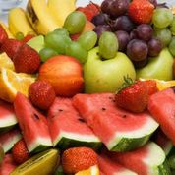  fruit | not enough
  pizza | a lot of
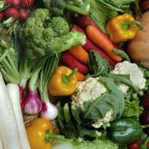  vegetables | too much
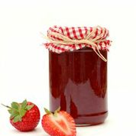  jam | too much
  pasta | a few
    choice | too many
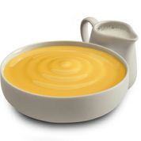  custard | some
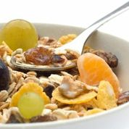  cereal | too many
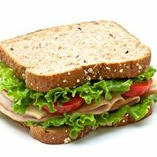  sandwiches | enough
  eggs | lots of
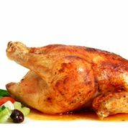  chicken | a bit of
  chips | too many

Extension resource 9: headlines – choose an adjective from the box to make a headline

fresh angry boring unhealthy

fat cheap overcooked frozen

1 Prison food _________________ (cooked too much) say prisoners.

2 Many prisoners have an _______________ (not healthy) diet.

3 Prisons use ________________ (not expensive) meat.

4 Eating lots of pies makes prisoners _________ (overweight).

5 A lot of prison food is _____________ (not interesting).

6 We do use ___________ (straight from the farm) fruit and veg says a prison chef.

7 Many prisoners _________________ (very, very unhappy) about prison food.

8 __________ (very, very cold) food lasts longer so is cheaper and means we can keep costs down says a Manager.

k c i n e h c

b v t l e s e g a e
t i s b c i u s

d s r a c t u

o s u p

s h i a n c d w
Extension resource 10: anagrams

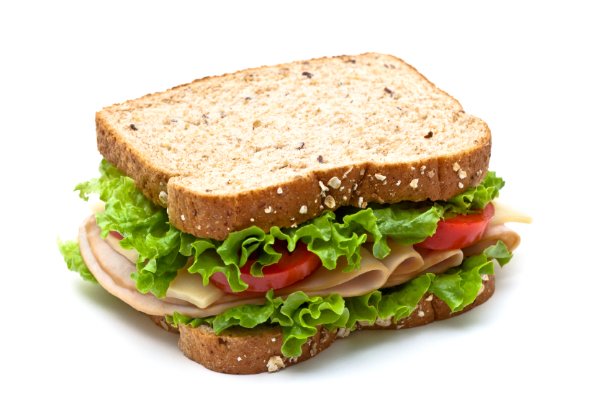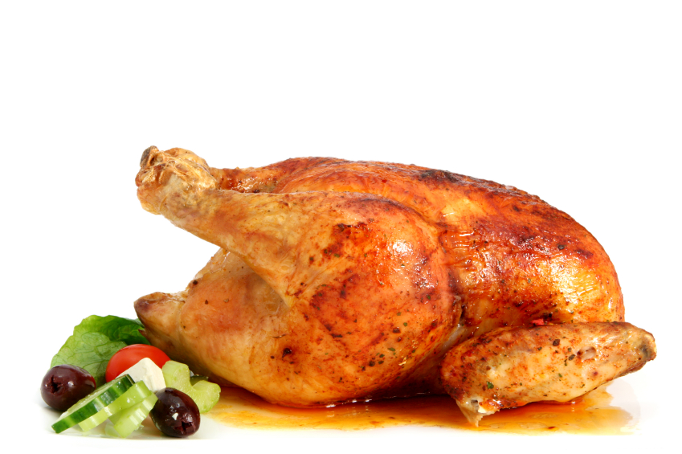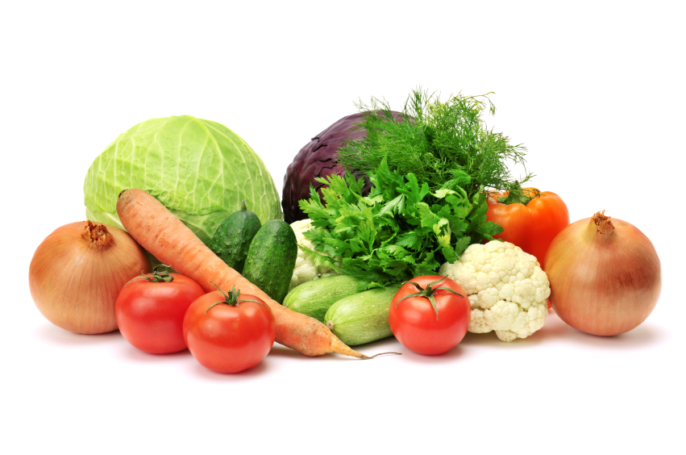

Answers
Resource 1 (left to right)
- fruit and vegetables
- fish and chips
- chicken
- pizza
- curry and rice
- salad
- shepherd’s pie
- vegetables
- sausage rolls
- bread/ baguette/ French stick
- custard
- cereal with fresh fruit
Resource 2 (suggestions only)
- tasty (pie)
- unhealthy (food)
- horrible (dinner)
- salty (chips)
- thick (custard)
- delicious (curry)
Resource 4a
Kevin OK isn’t much variety/always the same.
Sid OK not enough choice/choice is rubbish.
Paul X overcooked/doesn’t taste of anything.
Dan √ likes omelette/likes pasta and meat sauce
Resource 4b (differentiated)
Kevin OK He likes fish and chips. F
He has sandwiches at lunchtime. T
He eats his lunch in the dining hall. F
Sid OK The food tastes horrible. F
Sid isn’t a vegetarian. F
There are a lot of vegetables around in the summer. T
Paul X He loves prison food. F
There’s too much rice and pasta. T
He has an egg for breakfast. F
Dan √ He had an omelette with rice yesterday. F
He hates the pasta meals. F
They do lots of different sauces. T
Resource 6a
Kevin = not much variety/ aint (isn’t) much to choose from
Sid = not enough choice/ a lot of vegetables in the summer
Paul = too much rice and pasta/ aren’t enough vegetables
Dan = lots of different sauces.
Lenny (catering manager) = not enough fruit and vegetables/ a lot of prisoners would love/ a lot of fresh food/ a lot of things we grow
Resource 6b
- much
- enough
- a lot of
- too much
- a few
- some
- lots of
- some
- enough
Extension resource 9
- overcooked
- unhealthy
- cheap
- fat
- boring
- fresh
- angry
- frozen
Extension resource 10: Anagrams
- chicken
- vegetables
- biscuits
- custard
- cereal
- sandwich

